REPORT FOR STUDENT GRADING SYSTEM
OOP PROJECT

Include :
- Flow chart
- The actual python code
- Explanation about the code

Group member
- ESMA KURT 20241975
- ILKE KUDRET 20231450
- ENSAR ARIL 20231493
- MARIAMAWIT GUGSSA 20245431
- MOHAMMED ABDELWAHID 20244970

SUBMITTED TO: AMR ABDELBARI
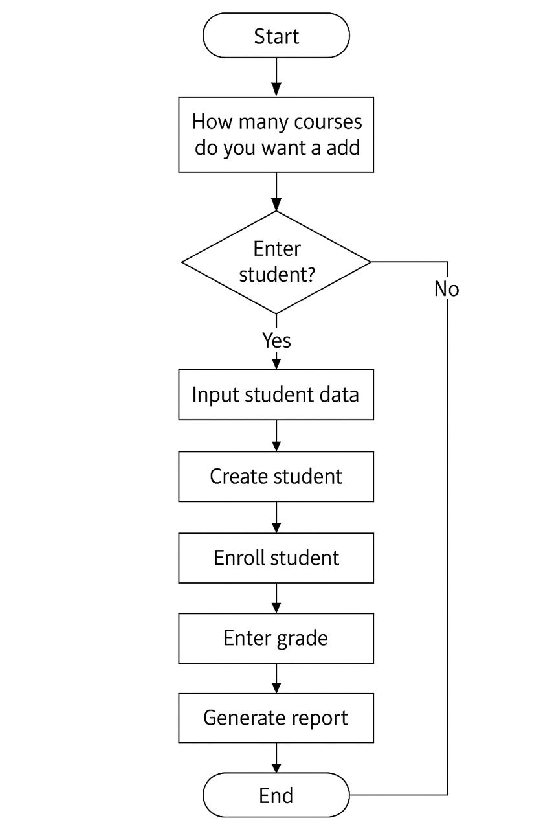FLOWCHART
class Student:
def __init__(self, name , age , student_id ,student_email , department):
self.name = name
self.age = age
self.student_id = student_id
self.email = student_email
self.department = department
self.grades = {}
self.attendance = []

def add_grade(self, subject, score):
self.grades[subject] = score

def get_total_score(self):
return sum(self.grades.values())

def get_average_grade(self):
if not self.grades:
return 0
return self.get_total_score() / len(self.grades)

def mark_attendance(self, status):
self.attendance.append(status)

def get_attendance_percentage(self):
if not self.attendance:
return 0
present_count = self.attendance.count("present")
return (present_count / len(self.attendance)) * 100

def get_status(self):
status_dict = {}
for subject, score in self.grades.items():
status_dict[subject] = "PASS" if score >= 50 else "FAIL"
return status_dict

class Course:
def __init__(self, course_name):
self.course_name = course_name
self.students = []

def add_student(self, student):
self.students.append(student)

def get_course_average(self):
if not self.students:
return 0
total = sum([self.get_average_grade() for s in self.students])
return total / len(self.students)

class SchoolManagementSystem:
def __init__(self):
self.students = {}
self.courses = {}

def add_student(self, student):
self.students[student.student_id] = student

def add_course(self, course):
self.courses[course.course_name] = course

def enroll_student(self, student_id, course_name):
student = self.students.get(student_id)
course = self.courses.get(course_name)
if student and course:
course.add_student(student)

def generate_report(self, student_id):
student = self.students.get(student_id)
if not student:
return "Student not found."
return {
"Name": student.name,
"Age": student.age,
"Department": student.department,
"Email": student.email,
"Grades": student.grades,
"Total Score": student.get_total_score(),
"Average Grade": student.get_average_grade(),
"Attendance %": student.get_attendance_percentage(),
"Status": student.get_status() }
def save_reports_to_excel(self, filename="student_reports.xlsx"):
import openpyxl
wb = openpyxl.Workbook()
ws = wb.active
ws.title = "Reports"
ws.append(["Student ID","Name","Age","Department","Email","Grades",
"Total Score","Average Grade","Attendance %","Status"])

for student_id, student in self.students.items():
report = self.generate_report(student_id)

ws.append([
student_id,
report["Name"],
report["Age"],
report["Department"],
report["Email"],
str(report["Grades"]),
report["Total Score"],
report["Average Grade"],
report["Attendance %"],
str(report["Status"]) ])

wb.save(filename)
print(f"Report saved to {filename}")

if __name__ == "__main__":
system = SchoolManagementSystem()

num_courses = int(input("How many courses do you want to add? "))

for i in range(num_courses):
course_name = input("Course name: ")
course = Course(course_name)
system.add_course(course)

print("Enter student (type 'Q' for name to quit) : \n")
while True:
name = input("Name : ")
if name == "Q":
break
age = int(input("Age : "))
student_id = int(input("Student_id : "))
email = f"{student_id}@std.neu.edu.tr"
print("Email:" , {email})
department = input("department : ")

s = Student(name , age , student_id , email , department)
system.add_student(s)

for student in system.students:
system.enroll_student(student_id, course_name)

print("\n Mark Attendance ")
for student in system.students.values():
while True:
status = input(f"Attendance for {student.name} (present/absent): ")
student.mark_attendance(status)

more_attendance =input("Add another attendance for this student? (yes / no): ")
if more_attendance == "no":
break

print("\n Enter Grade ")
for course_name in system.courses:
grade = int(input(f"{course_name} grade for {student.name}: "))
student.add_grade(course_name, grade)

print("\n Student Report ")
for student_id in system.students:
print(system.generate_report(student_id))
system.save_reports_to_excel("student_reports.xlsx")

Introduction
This assignment focuses on developing a School Management System using Python and Object-Oriented Programming (OOP) concepts. The system is designed to manage student information, courses, grades, attendance, and generate academic reports. It also allows saving student reports into an Excel file.
The project helps in understanding how OOP concepts can be applied to solve real-world problems in an organized and efficient way.

Objectives
The main objectives of this assignment are:
- To practice Object-Oriented Programming in Python
- To design and use multiple classes
- To manage student and course data
- To calculate grades and attendance
- To generate student reports
- To export reports to an Excel file

System Design
The system is divided into three main classes:
- Student
- Course
- SchoolManagementSystem
Each class has a specific role, which makes the program easy to understand and maintain.

Class Description

Student Class
The Student class stores personal and academic information of a student.

Attributes:
- Name, age, student ID, email, department
- Grades (stored in a dictionary)
- Attendance records

Methods:
- Add grades
- Calculate total and average grades
- Mark attendance
- Calculate attendance percentage
- Check pass or fail status

Course Class
The Course class manages course details and enrolled students.

Attributes:
- Course name
- List of students

Methods:
- Add students to the course
- Calculate the course average

SchoolManagementSystem Class
This is the main class that controls the whole system.
Functions include:
- Adding students and courses
- Enrolling students in courses
- Generating student reports
- Saving reports to an Excel file

Program Workflow
- The user enters course details.
- Student information is added to the system.
- Students are enrolled in courses.
- Attendance is recorded.
- Grades are entered for each course.
- Student reports are generated.
- Reports are saved in an Excel file.

Excel Report Generation
The system uses the openpyxl library to create an Excel file. Each student’s details, grades, attendance percentage, and status are stored in a table format. This makes the reports easy to view and share.

Conclusion
This assignment successfully demonstrates the implementation of a School Management System using Python and object-oriented programming principles. The system effectively manages students, courses, attendance, and grading while providing structured academic reports. With some improvements, it can be expanded into a more advanced application.

